Create Output Location to C:\Temp\

Run script from location you coped

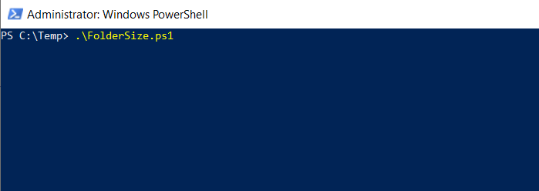

Supply folder path which you want to get size

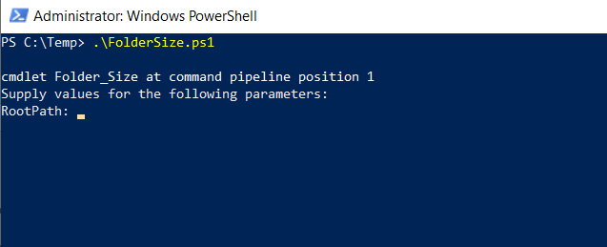

Like below

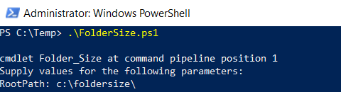

Once Script Completed

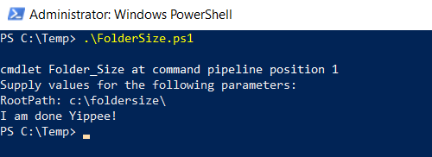

Validate CSV output file on output location you created C:\Temp\foldersize.csv

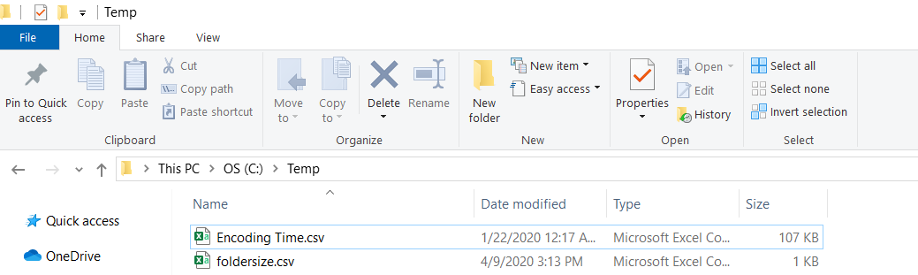

Output file sample.

